LPARDesign

**USER’S GUIDE**

**Version V14-T02**

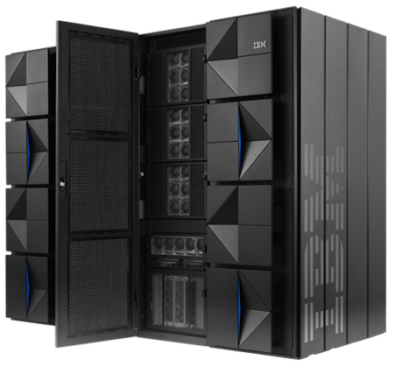 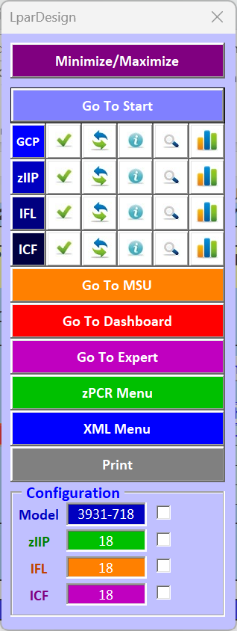

**Doc : LPARDesign-HD-zPCR-V14-T02_AMTD_UserGuide.docx**

**© 2024 AMTD**

**Updated: Nov 24th, 2024**

**Alain Maneville & Thierry Déléris**

Table Of Content

1. Introduction to LPARDesign Tool 4

2. DISCLAIMER OF WARRANTIES 5

3. ACKNOWLEDGEMENTS 5

4. HOW TO GET THE PRODUCT – IMPORTANT NOTICE: 6

4.1 Important Information. 6

4.2 From Github 6

5. CHANGES IN THIS RELEASE. 7

5.1 What’s new in V14T02 7

5.1.1 Support of zPCR 9.6.7 7

5.1.2 Weight Adjustment tool 7

5.2 What’s new in V14T01 7

5.2.1 Support of zPCR 9.6.6 7

5.2.2 LparDesign Tools put under MIT License 7

5.2.3 End of the 2:1 zIIP to GCP under z16 7

5.3 What’s new in V13T04 7

5.3.1 Support of zPCR 9.6.5 7

5.3.2 Optimization of the Expert System 7

5.4 What’s new in V13T03 7

5.4.1 Support of zPCR 9.6.4 7

5.5 What’s new in V13T02 7

5.5.1 Support of zPCR 9.6.2 7

5.6 What’s new in V13T01 7

5.6.1 Support of the z16 A02 & AGZ machine (M/T 3932) 7

5.6.2 Support of zPCR 9.6 7

5.7 What’s new in V12T01 7

5.7.1 Support of the z16 A01 machine (M/T 3931) 7

5.7.2 Support of zPCR 9.5 7

5.8 What’s new in V11T03 8

5.8.1 zPCR to LPARDesign : Study Import enhancement 8

5.8.2 Support for zPCR 9.4b 8

5.9 What’s new in V11T02 8

5.9.1 EXPERT recommendation (Rules#3 for GCP) 8

5.9.2 Support for zPCR 9.4a 8

5.10 What’s new in V11T01 8

5.10.1 Support for z15-T02 (8562) 8

5.10.2 Support for zPCR 9.4 8

5.10.3 Support of ICF configuration (standalone definition or imported from zPCR) 8

5.10.4 Dashboard environment Enhancement 8

5.10.5 Task Bar Enhancement 8

5.10.6 XML file creation for comparison purpose 8

6. THE NAVIGATION AND ACTION BAR. 9

6.1 BAR Functions 9

6.2 Weight adjustment tool 10

7. MANAGEMENT OF MESSAGES. 13

8. A BRIEF VIEW OF THE SPREADSHEET. 14

8.1 The START worksheet: 14

8.2 The CONFIG worksheet: 14

8.3 The CONFIG-MSU worksheet: 14

8.4 The CONFIG-ZXXP worksheet: 15

8.5 The CONFIG-IFL worksheet: 15

8.6 The CONFIG-ICF worksheet: 15

8.7 The EXPERT worksheet: 15

8.8 The SYNTHESIS worksheet: 15

8.9 The DASHBOARD worksheet 16

8.10 The Tables and SINET worksheets. 16

9. SPREADSHEET USAGE. 17

9.1 START SPREADSHEET Usage. 17

9.1.1 Specifying the Machine type (GCP) and/or #zIIP and/or #IFL and/or ICF. 17

9.1.2 Accept SPECIAL ConF? YES or NO. 17

9.1.3 Set / Change the Configuration for GCP, zIIP, ICF and IFL 18

9.1.3.1 Notes on LinuxONE machine support : 19

9.1.4 Always keep a fresh copy of the initial spreadsheet 19

9.2 CONFIG SPREADSHEET Usage. 20

9.2.1 Define the basic LPAR GCP configuration. 20

9.2.2 Validating the configuration – with  20

9.2.3 Validating the configuration – with:  21

9.2.4 Sorting selected columns. 22

9.2.5 Explanation of some columns. 22

9.2.6 Computing the HiperDispatch® number of LPs. 23

9.2.7 Linking to zPCR. 24

9.2.8 Deleting LPARs. 25

9.3 CONFIG-MSU SPREADSHEET Usage. 26

9.3.1 General usage notice: 26

9.3.2 LPAR and Capacity Definitions 26

9.3.3 Group Calculation 27

9.3.4 Other buttons functions: 28

9.3.5 Explanation of this tab header: 28

9.4 CONFIG-ZXXP SPREADSHEET Usage. 29

9.4.1 Only zIIP are supported in this release. 29

9.4.2 Support for Special Configuration for zIIPs: 31

9.5 THE CONFIG-IFL SPREADSHEET USAGE. 32

9.5.1 Sorting selected columns. 33

9.6 THE CONFIG-ICF SPREADSHEET USAGE. 34

9.6.1 Sorting selected columns 34

9.7 SYNTHESIS SPREADSHEET Usage. 35

9.8 EXPERT SPREADSHEET Usage. 36

9.8.1 EXPERT Notes for GCP. 36

9.8.1.1 The rules used for advices in GCP: 36

9.9 EXPERT Notes for zIIPs. 39

9.10 EXPERT Notes for IFL. 39

9.11 DASHBOARD SPREADSHEET Usage. 40

9.11.1 DASHBOARD for zIIP enhancement. 41

10. LINK with zPCR . 42

10.1 General considerations on this feature. 42

10.2 Current limitations of the link to zPCR feature. 42

10.2.1 Specifying an LPAR with unsufficient number of LPs to sustain the share 42

10.2.2 Processors type. 42

10.2.3 Reference CPU. 42

10.2.4 zPCR Version. 42

10.2.5 z/OS Version. 43

10.3 Using the zPCR EXPORT feature. 43

10.4 Using the zPCR IMPORT feature . 45

11. PRINTING THE SHEETS. 46

12. FAQ, COMMON MISTAKES AND RELEASE RECOMMENDATIONS. 47

12.1 FAQ 47

12.2 COMMON MISTAKES. 49

12.3 RELEASE RECOMMENDATIONS: 50

13. RECOMMANDED USAGE WORKFLOW 51

# Introduction to LPARDesign Tool

This document explains how to use the LPARDesign Tool.

This tool helps in configuring LPARs for all processor type HiperDispatch® eligible.

It provides the calculation of the number of HighShare, MediumShare and LowShare LPs when HiperDispatch® is available on the studied machine.

Here is a visual synthesis about the **LparDesign Tool** functions:

* *It let us work on a single PR/SM configuration to analyze, optimize, and study it*

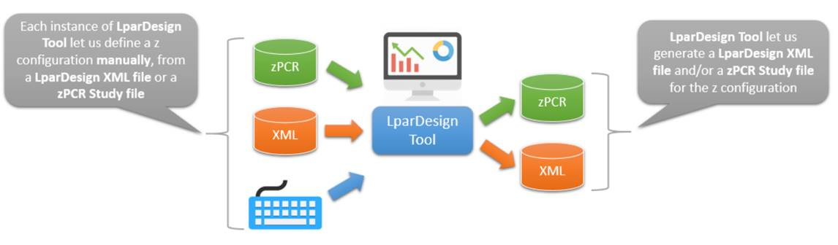

And here is a visual synthesis about **LparDesign Extended Tool** functions:

* *LparDesign Extended Tool is an add-on to LparDesign Tool*
* *It let us work with multiple PR/SM configurations produced thanks to the loading of the corresponding LparDesign Tool XML output files*
* *And so we could build some comparison dashboards between two PR/SM configurations or simply investigate from one PR/SM configuration to another*

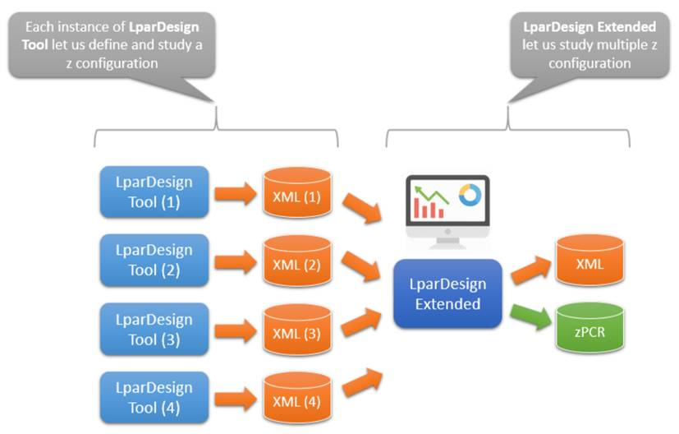

# DISCLAIMER OF WARRANTIES

***The following [enclosed] macro is sample code created by Alain Maneville – z Consultant.***

***This sample macro is provided to you solely for assisting you in the PR/SM LPAR ® and HiperDispatch® Configuration.***

***The code is provided "AS IS", without warranty of any kind. Thierry Deleris and Alain Maneville shall not be liable for any damages arising out of your use of such sample code, even if you have been advised of the possibility of such damage***

***Support: Support will be provided on a "best effort" basis. Send the spreadsheet for an analysis to thierry.deleris@orange.fr***

# ACKNOWLEDGEMENTS

I would like to thank the following people for their help and contribution to this worksheet

**Thierry DELERIS** – A customer (France).

He wrote the code of the DASHBOARD worksheet and did a great job for the zPCR link feature, the Task Bar and more!

**Robert VAUPEL** - The worksheet CONFIG-MSU comes from him. **This worksheet is now stabilized**.

# HOW TO GET THE PRODUCT – IMPORTANT NOTICE:

## Important Information.

Starting with this release, Predesign and LPARDesign Extended will only be available from GitHub. This version **will not be available from the IBM WLM site as before**.

## From Github

Due to a change in IBM’s way of managing WEB sites, the product is now available on the GitHub Web site at the URL:

[**https://github.com/ThDeleris/z-OS-LPARDesign**](https://github.com/ThDeleris/z-OS-LPARDesign)

You will get this page :

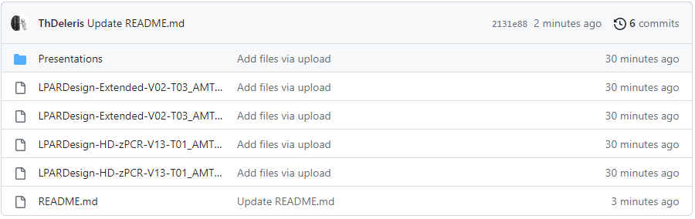

Then, Click on the LPAR Design Hyperlink for the spreadsheet **AND** the User’s Guide to download them.

# CHANGES IN THIS RELEASE.

## What’s new in V14T02

### Support of zPCR 9.6.7

### Weight Adjustment tool

This new Task Bar option lets you choose to automatically adjust the weights of your GCP/zIIP/IFL/ICF configuration. Two methods are available:

* *Weight adjustment based on Share%*
* *Weight adjustment based on Guaranteed Physical Processor*

## What’s new in V14T01

### Support of zPCR 9.6.6

### LparDesign Tools put under MIT License

### End of the 2:1 zIIP to GCP under z16

Since the z16 the 2:1 zIIP to Central Processor (GCP) ratio requirement no longer applies to make broader use of the zIIP specialty engine.

## What’s new in V13T04

### Support of zPCR 9.6.5

### Optimization of the Expert System

## What’s new in V13T03

### Support of zPCR 9.6.4

## What’s new in V13T02

### Support of zPCR 9.6.2

## What’s new in V13T01

### Support of the z16 A02 & AGZ machine (M/T 3932)

### Support of zPCR 9.6

## What’s new in V12T01

### Support of the z16 A01 machine (M/T 3931)

### Support of zPCR 9.5

## What’s new in V11T03

### zPCR to LPARDesign : Study Import enhancement

You can now choose which study to Import to LPARDesign when you have “multiple studies” defined in the zPCR deck.

### Support for zPCR 9.4b

## What’s new in V11T02

### EXPERT recommendation (Rules#3 for GCP)

There is a new way of proposing a configuration enhancement for this rule.

The current way is proposing an enhancement to have one more VH but removes some LPs

The new way is to propose adding a VH in keeping the same number of LP.

### Support for zPCR 9.4a

## What’s new in V11T01

The V11-T01 version is a major redesign of the tool.

### Support for z15-T02 (8562)

The z15-T02 (8561) is supported is this release

### Support for zPCR 9.4

### Support of ICF configuration (standalone definition or imported from zPCR)

The ICF configuration is now imported or exported to/from zPCR.

This will make the link to and from zPCR totally transparent as the ICF (even not HD eligible) are now included.

### Dashboard environment Enhancement

When LPAR have DED LPs the color has been changed in dark green

When LPAR does not have zIIP allocation, the color has been changed to dark grey

ICF is now included in the Dashboard

### Task Bar Enhancement

The Task Bar includes the ICF buttons

The Task Bar includes the XML menu which is now operative

### XML file creation for comparison purpose

This was a long-time request. You can now save your LPARDesign studies and load them in a new spreadsheet – LPARDesign Extended to compare the configurations.

LPARDesign Extended is a companion Tool and has its own macro and User’s Guide.

# THE NAVIGATION AND ACTION BAR.

To make things simpler and easier, a new navigation and action BAR is provided.

It is available when you open the spreadsheet and stays until you close it.

You can move it anywhere in the worksheets (you will do that when first opening the product).

## BAR Functions

It is now easier when you are in a particular PU configuration to view the EXPERT or the DASHBOARD.

At any time, you can see your general configuration, validate it and check it.

**Again, any change in the number of PU must be done in the START worksheet!**



Sliding the mouse pointer to one of the icons shows its function.

## Weight adjustment tool

This new Task Bar option lets you choose to automatically adjust the weights of your GCP/zIIP/IFL/ICF configuration. Two methods are available:

- Weight adjustment based on Share%

- Weight adjustment based on Guaranteed Physical Processor

*This tool is partly based on Jim Horne’s SHARE presentation about an alternative method for managing LPAR weights. Mr Horne’s methodology is designed to make it easier to manage your HiperDispatch topology – an important consideration for any modern mainframe configuration:* [*Reprrint of ’Benefits of Analysis Across SMF Data Types’ article from Cheryl Watson’s Tuning Letter 2023 No. 1.*](https://watsonwalker.com/wp-content/uploads/2023/09/Reprint-of-Jims-LPAR-Management-article.pdf)

***For this chapter we will use the LparDesign sample GCP configuration :***

To start an adjustment first click on the button  in the Task Bar for the processor type configuration you want to adjust (GCP/zIIP/IFL/ICF). The following menu will be displayed:

*Note: The “****Reload previous Weight****” option is disabled until the first adjustment will be done.*

If we click on the “**Weight Adjustment based on %Share**” option, the process starts and then we will get the following pop-up:

The resulting Weights are the following ones where the Weight of each LPAR is now equal to the %Share of the LPAR multiplied by 100:

The “**Reload previous Weight**” option is now enabled as we have done an adjustment:

If we click on the “**Weight Adjustment based on Guaranteed Physical Processor**” option, the process starts and then we will get the following pop-up:

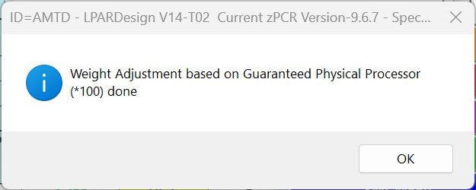

*Note: The results for the LPARs weights will be equal to the Guaranteed Physical Processor values multiplied by 10 rather than by 100 when it’s a better option taking the maximum Guaranteed Physical Processor value into account.*

If we click now on the “**Reload previous Weight**” option, the previous weights will be reloaded and then we will get the following pop-up:

# MANAGEMENT OF MESSAGES.

All the messages (validation, error and so on) will be now displayed in a single box.

This prevent to have to click “OK” after each message.

An example in given in this picture:

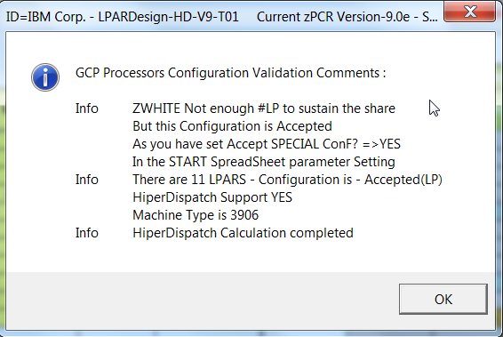

At any time, you can review these messages for a particular PU type by clicking on the  Icon.

# A BRIEF VIEW OF THE SPREADSHEET.

The spreadsheet is now composed of 9 worksheets:



## The START worksheet:

This worksheet is opened automatically when you start the workbook.

You must use it to set the number of GCP, zIIP nd IFL and to set your “special configurations” parameter.

Then you can specify a “Study ID” that will be used in the spreadsheet or in the zPCR study.

**The only way to change the value of GCP, zIIP and IFL is to go back to the START worksheet.**

You can go to this START worksheet by clicking on the  button on the navigation Bar.

A check of a mix of these processors will be done before you can go to the various LPAR Definition.

Other functions provided are:

* Create a copy (so you can always have a basic version of the tool)
* Save as (to save you work)
* The navigation Bar will let you go to others functions for this particular PU or to other functions..

## The CONFIG worksheet:

This worksheet helps you define:

* The LPARs characteristics for the GCP (as you would do on the HMC)
* Validation of the LPAR configuration and Calculation of the HiperDispatch® processor in HighShare, MediumShare and LowShare LPs using the navigation Bar  icon.

Note : The Machine type and model are now changed only in the START worksheet.

Other functions provided are:

* Delete LPAR(s)
* Create a ***.zPCR*** study file or update an LPARDesign spreadsheet with an existing ***.zPCR*** study file.
* The navigation Bar will let you go to other functions for this particular PU or to other functions.
* Sorting (ascending and descending) of selected columns.

Other functions provided are in the navigation BAR:



## The CONFIG-MSU worksheet:

This worksheet helps you define:

* The DEFINED CAPACITY values for a single LPAR.
* A GROUP CAPACITY value for a set of LPARs.

The calculations and information provided are explained in the spreadsheet usage section specific to this spreadsheet.

## The CONFIG-ZXXP worksheet:

This worksheet helps you define:

* The LPARs characteristics for the zIIP (as you would do on the HMC).

Other functions provided are in the navigation BAR:



## The CONFIG-IFL worksheet:

This worksheet helps you define:

* The LPARs characteristics for the IFL (as you would do on the HMC).

Other functions provided are in the navigation BAR:



## The CONFIG-ICF worksheet:

This worksheet helps you define:

* The LPARs characteristics for the ICF (as you would do on the HMC).
* Note: ICF are not eligible PU for HiperDispatch® - this configuration is there to fully support a zPCR study

Other functions provided are in the navigation BAR:



## The EXPERT worksheet:

This worksheet might help you optimizing your current configuration for:

* GCP, zIIP and IFL.

You choose the EXPERT recommendations you want by clicking on the appropriate button on the top of the worksheet or directly  in the navigation BAR.



## The SYNTHESIS worksheet:

This worksheet shows the HiperDispatch® effects for the GCP, zIIP and IFL.

## The DASHBOARD worksheet

This worksheet provides a view of the processor layout for:

* GCP, zIIP, IFL and ICF.

You choose the DASHBOARD you want by clicking on the appropriate button on the top of the worksheet or directly  in the navigation BAR.

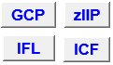

## The Tables and SINET worksheets.

These are management worksheets. **Do not alter them!**

# SPREADSHEET USAGE.

**ONLY CELLS IN YELLOW SHOULD BE FILLED.**

**USE THE navigation BAR TO NAVIGATE WITHIN WORKSHEETS.**

**CONFIGURATION DATA MUST BE CHANGED IN THE START WORKSHEET**

When you open the workbook, you are automatically directed to the START worksheet.

Important changes have been done in this release, the START worksheet is now the only place to change the configuration of the PU.

The navigation BAR is displayed too. You can move it anywhere if needed.

## START SPREADSHEET Usage.

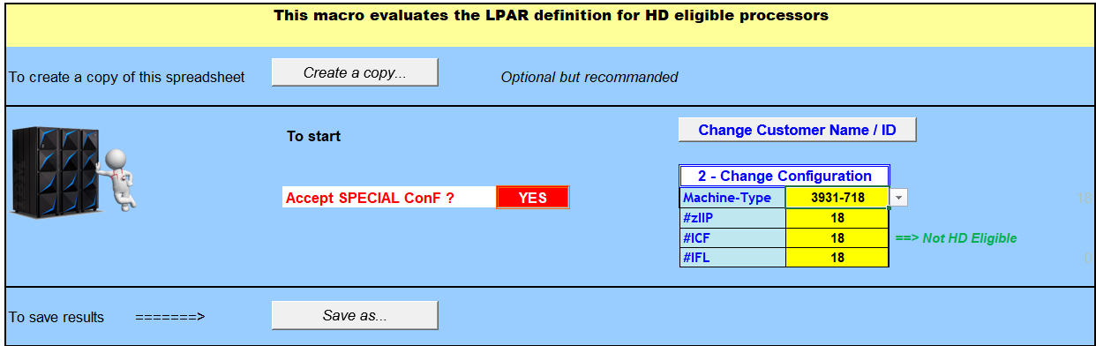

You can specify an identification of you study that will be set in the ID= field of the various titles. You can change it using the  button.

The LPARDesign version and the current zPCR version are displayed in the first row of the sheet.

### Specifying the Machine type (GCP) and/or #zIIP and/or #IFL and/or ICF.

This is now the place you do these specifications. If you want to change them, you must go back to this spreadsheet by clicking on the  button on the navigation BAR.

### Accept SPECIAL ConF? YES or NO.



PR/SM accepts configurations where the number of the HMC defined LPs is not consistent with the number of LPs needed to sustain the share of the LPAR.

This might happen in some Ksys GDPS LPAR configuration or if the customer defines “White Space” LPARs.

To inform the process that you will accept special configurations, just say YES in the proposed choices.

The effects of saying “YES” will be explained in the CONFIG sheet usage.

To run with the regular process, say “NO”.

### Set / Change the Configuration for GCP, zIIP, ICF and IFL

You can now specify all the full configuration in terms of Machine-Type (GCPs), zIIPs and IFLs.

Some validations are done to check the health of these settings (for example, do not specify zIIPs for an IFL only machine).

The following cells should be filled:

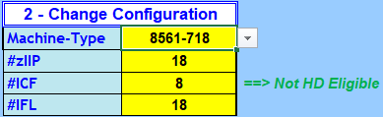

All the fields are lists so you can use the button on the right of the fill area to scroll within them.

Note: for IFL only machines (Like EMPEROR), you will find machines where the type ends by **00**. For example, 2964-7**00** or 3906-4**00** – this means that NO GCP are available for this machine as it is an IFL only machine.

Example of an IFL only machine selection:

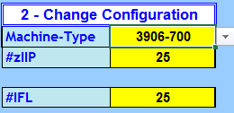

Here you have chosen a 3906-7**00** which contains NO GCP.

With this very configuration, suppose now that you press the  Icon for the IFL configuration validation.

As you have left 25 zIIPs, you will get an error message:

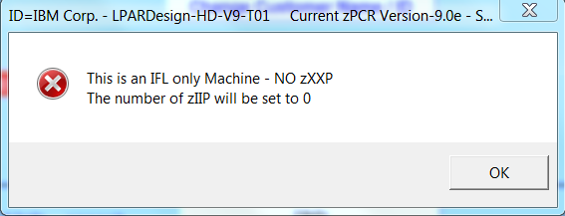

After pressing OK, the number of zIIP will be set to 0 and the Change Configuration will look like:

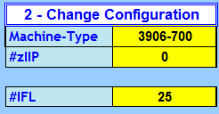

Of course, you can mix [GCP / zIIP], ICF and IFLs.

#### Notes on LinuxONE machine support :

To make the spreadsheet easy and efficient, LinuxONE machine will be only supported as **IFL only machine** executing z/VM as virtualization software.

When you are done with all these settings **it is mandatory to click the**  Icon. This will check your settings and will bring you to the CONFIG (GCP) worksheet or, if you have an IFL only machine to the CONFIG-IFL worksheet.

### Always keep a fresh copy of the initial spreadsheet

**It is recommended to always have a fresh copy of the initial spreadsheet – so the  button is useful for that.**

## CONFIG SPREADSHEET Usage.

### Define the basic LPAR GCP configuration.

There is a cell  containing the number of currently defined LPARs. We did that because of the IFL and ICF configuration, so we needed to check that the number of LPARs (GCP+IFL+ICF) does not exceed the total number of LPAR supported by the machine.

Just fill the cells in yellow as you would fill the definition at the HMC.

Here is the new layout of the CONFIG spreadsheet before the validation.

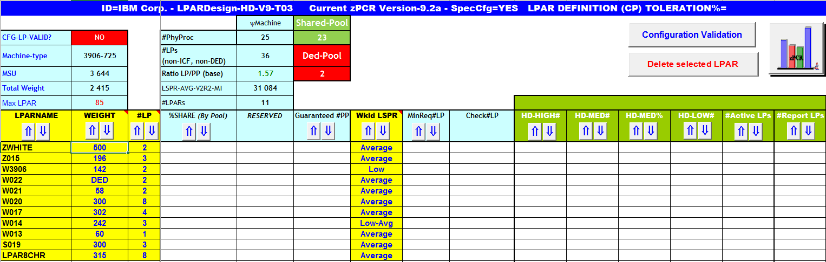

Note: The  column is filled manually or automatically when you import a zPCR study. This column is for compatibility purpose with zPCR and has no impact for the HiperDispatch® calculation. You can choose (manually) your setting in the following list:

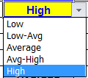

The CPC has already been chosen in the START worksheet. You just must configure the LPARs with their name, Weight (Weight value or **DED** for dedicated LPs) and number of LPs as you would do in the HMC definition.

### Validating the configuration – with

This is the regular way of validating the configuration.

Then click on the  button (old way) or in the  Icon for GCP.

This will check that the parameters are correctly set.

If errors occur, an error box is displayed; the Check/LP column is filled with the specific error.

The  is set to NO

You then must correct the errors; rerun the validation until you have  displayed.

Note: starting with the z13 machine, a cell is displayed. So now, we have 4 possible values: 30, 40, 60 or 85 LPARs.

The cell  gives the maximum number of LPAR than can be defined in the machine.

### Validating the configuration – with:

In this case, you will accept configurations **where** the number of HMC defined LPs **is not consistent** with the number of LPs needed to sustain the share of the LPAR.

The process of validating this kind of configuration has been added and is as follow:

* If the number of defined LPs is less than the number of LPs required to sustain the share of the LPAR, a message will be displayed, BUT, the configuration will be accepted.
* Let’s take this example with a focus on the **ZWHITE** LPAR:

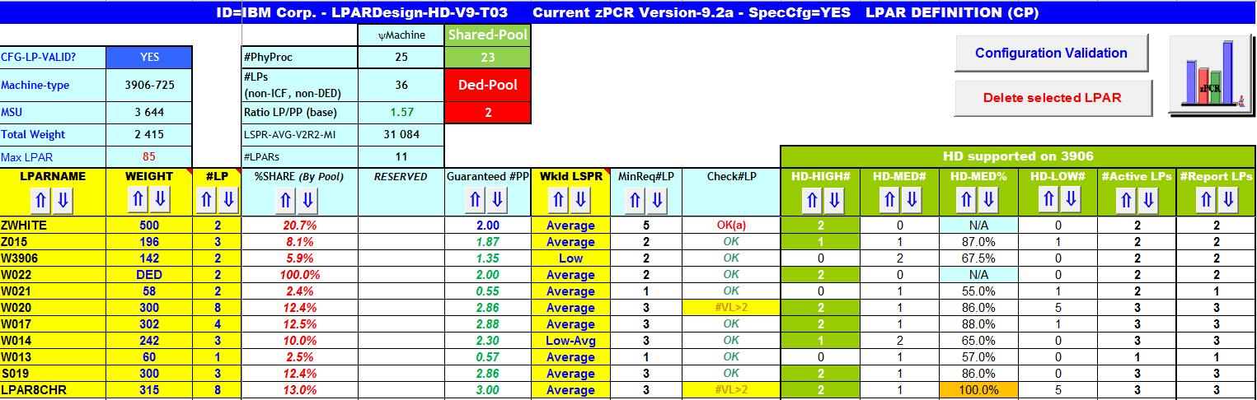

We see that ZWHITE LPAR has a Weight of 500 which gives a %Share of 20.7% of the Shared Pool and thus needs a Minimum Required #LP of 5.

But only 2 LP are defined, and this is done on purpose.

During the process, the following pop-up message will be displayed:

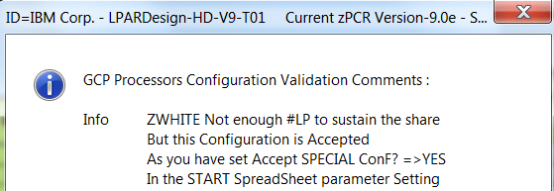

The LPAR definition will be accepted and the Guaranteed#PP (a key value for HiperDispatch® computing) will be replaced by the number of LPs set in the #LP column.

To reflect this “acceptation” the Guaranteed#PP column is set to bold and blue and the Check#LP column will receive the value **OK(a).**

After the validation, the regular HiperDispatch® process can carry on but it will use the “replaced” value in Guaranteed#PP.

### Sorting selected columns.

The capability of sorting selected columns is there:

These columns have the buttons  in their header. Sort can be Ascending or Descending depending on the button you push.

Only columns that have these buttons can be sorted. The following picture shows what columns you can sort on the CONFIG sheet.

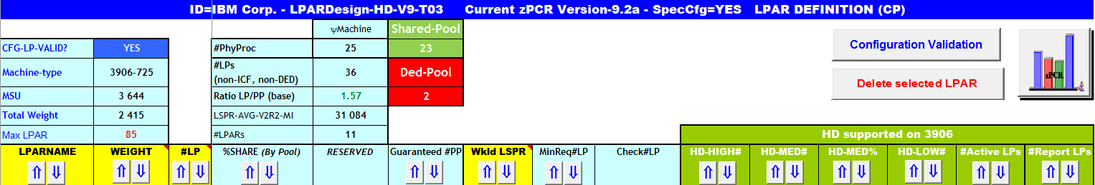

Note: sorting on the CONFIG sheet will sort (on the same column name) the related column on the other two sheets:

CONFIG-zXXP – because the LPARNAME is derived from the CONFIG sheet

CONFIG-MSU – because the LPARNAME, #LP and Weight are derived from the CONFIG sheet

### Explanation of some columns.

 - gives the %SHARE of the LPAR (by pool of LP, Shared / DEDicated)

 - This is: “%SHARE x #of Physical processors (shared pool)” – a fundamental metric for the HiperDispatch calculation.

Note: with  this value is not calculated but replaced by the number of defined LPs.

- This gives the minimum number of LP needed to sustain the %SHARE.

Note: with  and if there are less defined LPs than required, this column will have the value: 

All the message boxes display the current supported zPCR Version.

The  column is currently used to display information messages like “rules” for a specific machine (for the GCP processing at that time).

### Computing the HiperDispatch® number of LPs.

Just push the appropriate button or Icon and the following columns will be filled with the calculated values.



**HD-HIGH#:** #of HighShare LPs or **VH**

**HD-MED#:**  #of MediumShare LPs or **VM**

**HD-MED%:** Entitlement of the MediumShare LPs

**HD-LOW#:** #of LowShare LPs or **VL.**

**#Active LPs**: This is the number of real life active LPs considering that WLM will always “UnPark” a LowShare LP in a 2 LP configuration with a MediumShare LP and a LowShare LP. This number can be compared to the number of LP you initially set for the LPAR to evaluate the HiperDispatch® effect.

**#Report LP**: The sum of VH and VM according to the basic HiperDispatch® LP spread calculation. This number is the one reported by RMF but remember that on a 2 LP configuration the second LP is always UnParked.

When the calculation is completed you will receive this pop-up box:

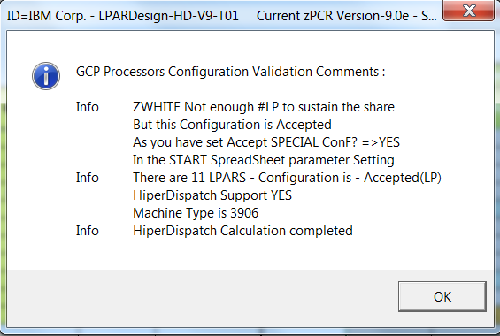

Otherwise, error messages will be sent.

The colors of the LP entitlement have been set to highlight HighShare LPs or MediumShare LPs that have an entitlement of 100% as shown in the below picture:

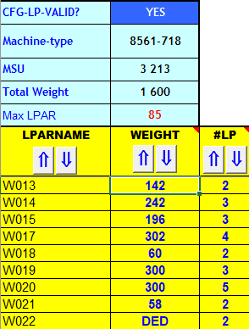 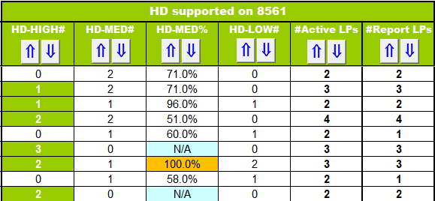

LPAR W020 has 2 VH LPs, 1 VM@100% and 2 VL - so you can see the way the cells are colored.

In this case, a VM is needed to be the anchor point of future UnParked VLs

A warning message will be displayed in the Check#LP column if the number of VL is > 2 as shown in this example:

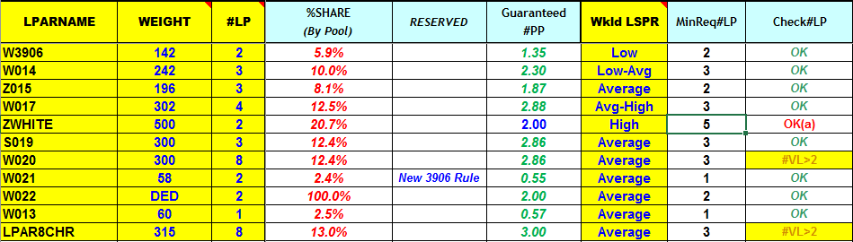

LPARs W020 and LPAR8CHR have this warning.

### Linking to zPCR.

When the button  is pressed, this will create a *.zpcr* study file from the LPARDesign spreadsheet or will update the current LPARDesign spreadsheet with an existing *.zpcr* study file. **See the chapter LINK with zPCR** for more information.

Or you can use the  button in the Task Bar to call the zPCR link.

### Deleting LPARs.

A button  is provided to properly delete selected LPAR. This was a long term requirement as it is not allowed to delete an LPAR with just deleting the EXCEL row containing this LPAR: after manual deletion, the number of row was less than expected and this was producing errors in the spreadsheet.

To delete LPAR(s):

* Select the LPAR(s) you want to delete
* If you want to delete more than one LPAR , select the first one, **keep the CTRL key pressed**, then select the other LPARs.

In this scenario, LPARs W014 and W018 are selected:

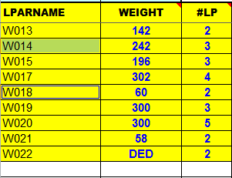

Then press the  button and you will get the following message box:

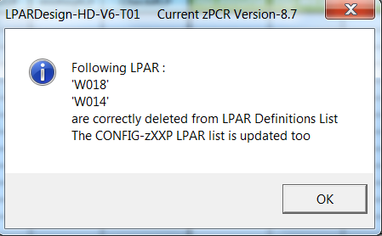

Note that the deletion has been done in the CONFIG-zXXP and the CONFIG-MSU too.

Never delete a row in any Worksheet!

## CONFIG-MSU SPREADSHEET Usage.

### General usage notice:

As usual the LPAR’s Name, #LCP and Weight are taken from the CONFIG spreadsheet, so only the yellow columns named:

Defined Capacity Limit

Capacity Group Name

Capacity Group Limit [MSU]

have to be filled to use this part of the tool.

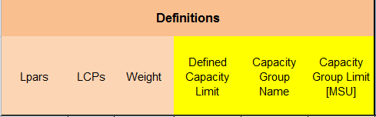

One possibility on modern z Systems with z/OS is to control the MSU consumption with the help of group capping. Group capping provides the fact that partitions can consume more MSU during a capping phase when other partitions of the same capacity group do not require their capacity share. On the other hand it is often difficult to understand how the partitions are being capped especially when group capping and individual defined capacity limits are combined. The Config-MSU tab provides some assistance in identifying the capping mechanism for the partitions under the assumption that all partitions request their capacity share during the capping phase. Figure 1 shows an example for an environment with 6 partitions from which 5 belong to a capacity group GRP1, and two of these partitions have individual defined capacity limits.

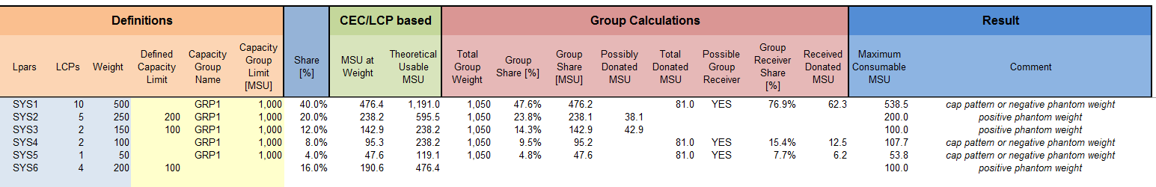

Figure 1 CONFIG-MSU Example

### LPAR and Capacity Definitions

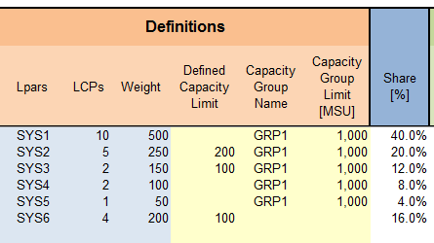

The definitions part shows the defined LPARs, the number of logical processors (LCPs) per partition, and the weight of each partition. The weight determines the “Share [%]” each partition has from the CEC. The Capacity definitions encompass a possible Defined Capacity Limit for each partition, the Group name if the partition belongs to a capacity group and the Capacity Limit of the Group.

Figure 2 CONFIG-MSU Definitions

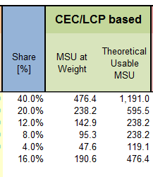

The next part of the spreadsheet converts the weight definition into an MSU value. MSU at Weight tells how much MSU are guaranteed to the partition by its weight definition. The theoretical usable MSU value describes how many MSU can be consumed when all LCPs of the partition are used to 100%.

Figure 2 Usable MSU for each partition

### Group Calculation

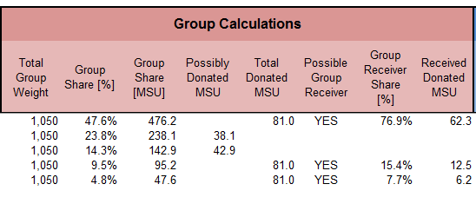

Figure 3 Group Calculations

Figure 4 depicts group related metrics. For distributing the MSU within a group it is necessary to understand the total weight of all partitions within the group as well as the share of each partition within the group. The group share is expressed as a percentage value and a MSU value.

If a partition has a defined capacity limit which is smaller than its Group share, the partition is not able to consume all of the MSU which it is entitled to by the group definition. The MSU which it is not able to use can potentially by donated to other partitions when group capping and individual capping is in effect for the partition. The “Total Donated MSU” can now be distributed between the receiver partitions. Each receiver has a share based on its weight and receives the corresponding portion of the total donated MSU.

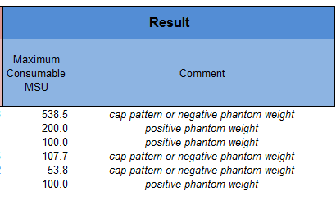

The result section now tells how much MSU each partition can consume under the assumptions that all partitions use their share and that all capping limits are being reached. The Comment column then displays which capping technology is being used.

Figure 4 Group Capping Results

Notice: Starting with zEC12 GA2 and z/OS 2.1 the **cap pattern technology has been replaced by a negative phantom weight technology**, therefore which technology is being used depends on the hardware and software level.

### Other buttons functions:

 This will clear the MSU definitions (Yellow columns)

 This will clear the calculation part after a partial modification of the definitions

 When the definitions are ok, press this button to calculate them. The following information box will appear:

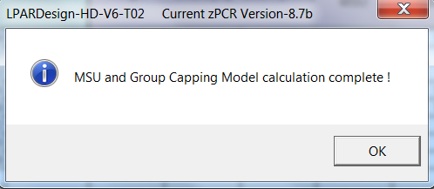

### Explanation of this tab header:

The LPAR configuration is taken from the CONFIG tab.

DEDicated processors may exist in the definition – if it is the case this particularity is shown in the Shared Pool cell when the number of physical processor in the Shared Pool is different from the number of physical processors of the actual physical machine.

This is shown in the following example:



The definitions of this example are:

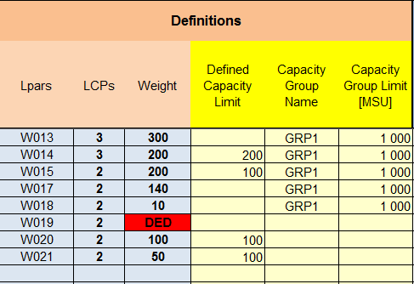

The physical machine has 12 PCP

But we have an LPAR (W019) with 2 DEDicated PCP

So the Shared Pool is 10 PCP

Note#1: The Weight cell format of the DEDicated LPAR is in red.

Note#2: sorting on the CONFIG sheet will sort (on the same column name) the related column on two other worksheets:

CONFIG-zXXP – because the LPARNAME is derived from the CONFIG sheet

**CONFIG-MSU** – because the LPARNAME, #LP and Weight are derived from the CONFIG sheet

## CONFIG-ZXXP SPREADSHEET Usage.

### Only zIIP are supported in this release.

Once you are done with the CP configuration you can use the  set of Icons to be directed to the zIIP configuration spreadsheet if needed.

**The LPAR NAMES are automatically filled from the CONFIG sheet.**

**Never delete an LPAR in this sheet – do it from the CONFIG sheet and use the “Delete selected LPAR” button**

**Remember**: The number of zIIP has been filled in the START spreadsheet and can be seen in 

If you want to change it, go back to the START spreadsheet.

Note that the rule concerning the total number of zIIP is enforced and checked (2 zIIP / 1 GCP).

**It is not the standard rule which is based on the number of purchased CP, but we cannot know what this number is.**

Then fill the Weight (Weight value or DED for dedicated zIIP) and number of LPs for each LPAR.

Clear the cells (Weight and number of LP) for the LPARs that are not concerned by the zIIP configuration.

**NEVER clear the LPAR name**.

Then, click on the  button (old way) or the  Icon for zIIP.

This will check the configuration and calculate the HiperDispatch® number of LPs.

If errors occur, an error box is displayed and character “E” is set on the Error column of the current LPAR:

Example of error – the machine has **25** physical zIIP, but one has defined **26** LP in the W020 LPAR:

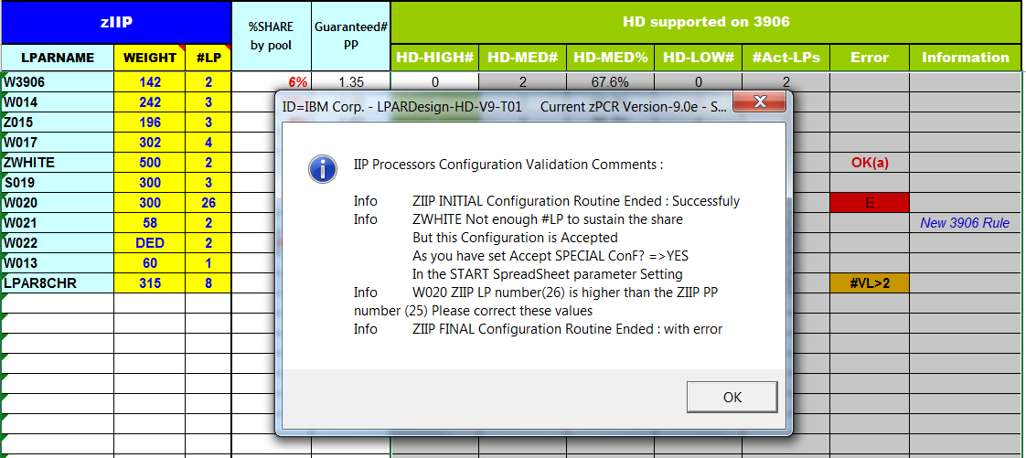

The column named  has the same meaning that the one in the CONFIG spreadsheet.

The zXXP configuration is checked in two phases:

* One for the Configuration Validation (e.g.: LP numeric and so on). Its name is “Initial Configuration”.
* One for the HiperDispatch® Configuration calculation. Its name is “Final Configuration”.

A new  column has been added to provide specific information for a specific machine rule.

Note#2: sorting on the CONFIG sheet will sort (on the same column name) the related column on two other worksheets:

**CONFIG-zXXP** – because the LPARNAME is derived from the CONFIG sheet

**CONFIG-MSU** – because the LPARNAME, #LP and Weight are derived from the CONFIG sheet

### Support for Special Configuration for zIIPs:

This is the same rule than for GCP configuration.

If you want to set a number of zIIP LPs that is below the number of required zIIP LPs, you can do it by selecting  in the START spreadsheet (this information will be the same for both GCP and zIIP).

When you are in the situation where the number of zIIP LPs is below the number of required LPs and you have selected this option, you will have this message box(read the information for the ZWHITE LPAR) :

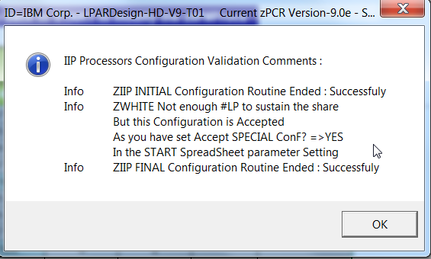

And the target LPAR will have its number of guaranted LP in bold/blue as shown below for the ZWHITE LPAR :

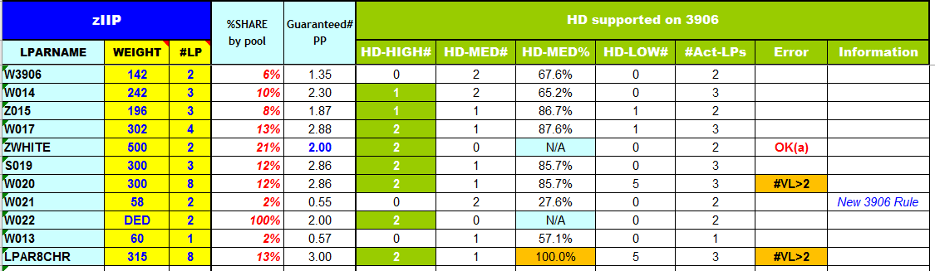

In the error colum, the characters **OK(a)** will be displayed too.

The recommendation on the number of VL is displayed too (as for W020 and LPAR8CHR LPARs).

## THE CONFIG-IFL SPREADSHEET USAGE.

As for GCPs, just fill the cells in yellow.

Remember that the number of IFLs has been set in the START spreadsheet. This is the only place to change it.

Here is the layout of the spreadsheet:

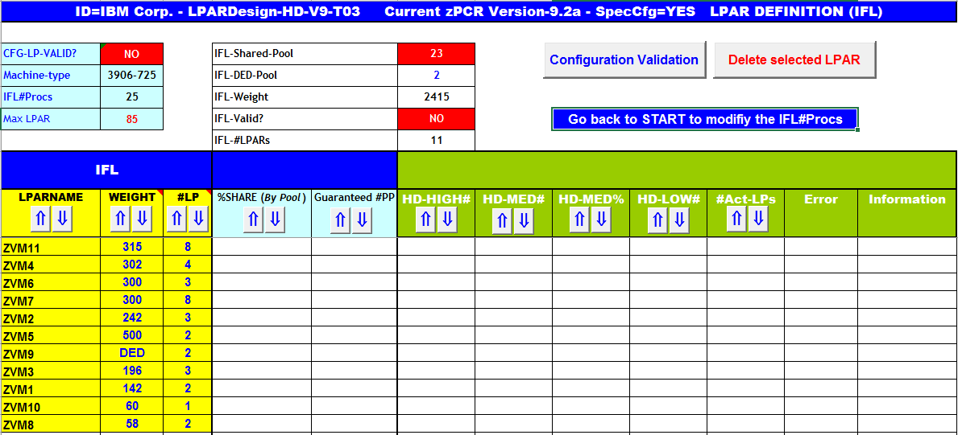

You must specify the **LPAR Name** as it cannot be copied from somewhere else (as for zIIP).

The configuration validation is done in two steps as for zIIP (INITIAL and FINAL).

As for GCPs you can properly delete an LPAR.

If you have GCPs too, **you must validate the GCP configuration before validating the IFL configuration** otherwise you will get this error message:

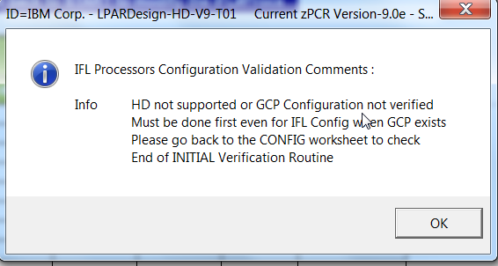

Note: depending on the way you have entered the number of IFL, you will be automatically directed to this IFL configuration spreadsheet – this is the case for an IFL only configuration.

Here is the spreadsheet after having clicked on the  button (old way) or in the  Icon.

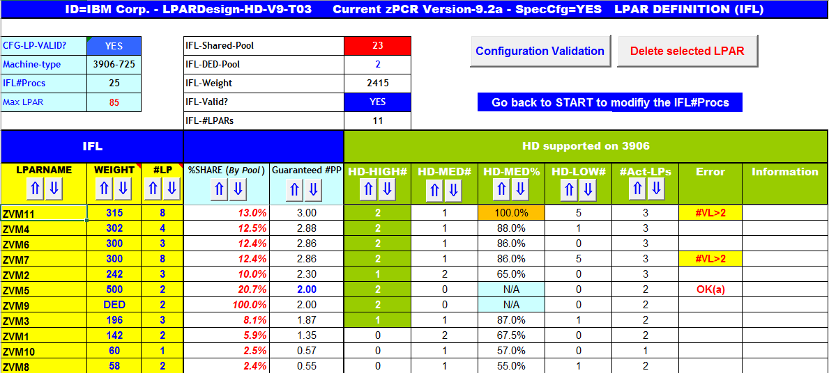

All the rules and error messages are the same as for GCP.

### Sorting selected columns.

We have introduced the capability of sorting selected columns.

These columns have the buttons  in their headers. Sort can be ascending or descending depending on the button you push.

Only columns that have these buttons can be sorted. The following picture shows what columns you can sort on the CONFIG-IFL sheet.

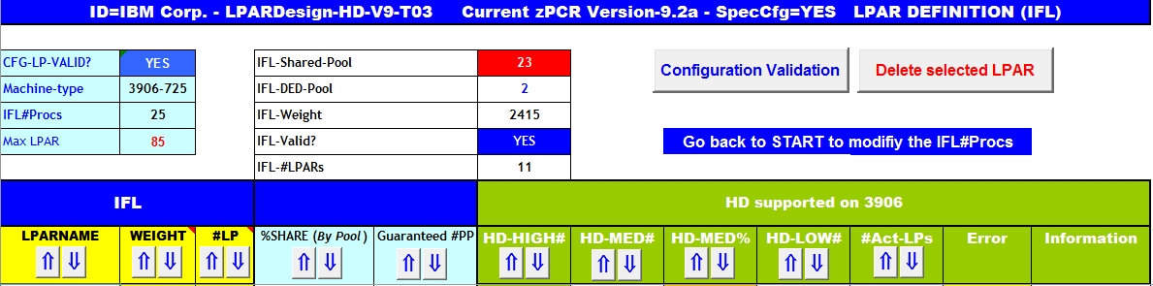

## THE CONFIG-ICF SPREADSHEET USAGE.

For the link with zPCR to be complete, the transfer of the ICF configuration that might be include in a zPCR study is available.

ICFs are not HiperDispatch® eligible, so a simple calculation of the %Share is done in this spreadsheet.

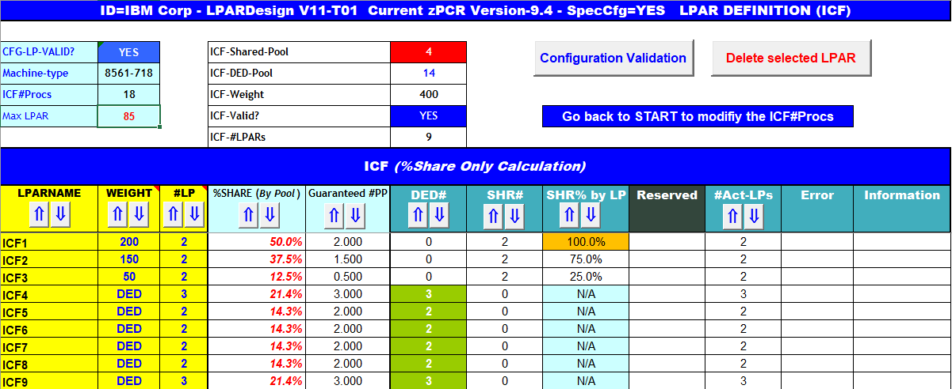

Here we have a %Share by pool (DED or Shared

The Guaranteed #PP is available to check if the correct number of LP has been set to sustain the Share.

Of course, all the usual error messages are available and the calculations are compliant with the “Accept Special Config” rules.

Note the  column: it shows what is the %Share for each LP of the LPAR.

In the previous example, we can see that LPAR ICF1 has a Guaranteed #PP of 2 and we have set 2 LPs, So each LP will have a %Share of 100% - In this case we set a color in the cell.

LPAR ICF2 has a Guaranteed #PP of 1.5 and we have set 2 LPs. So each LP will have (1.5/2)*100 giving 75% of %Share.

This is a usual calculation in horizontal mode.

### Sorting selected columns

You can sort the data using the  buttons (ascending and descending)

## SYNTHESIS SPREADSHEET Usage.

The result of the HiperDispatch® activation can be viewed in the SYNTHESIS spreadsheet as shown below.

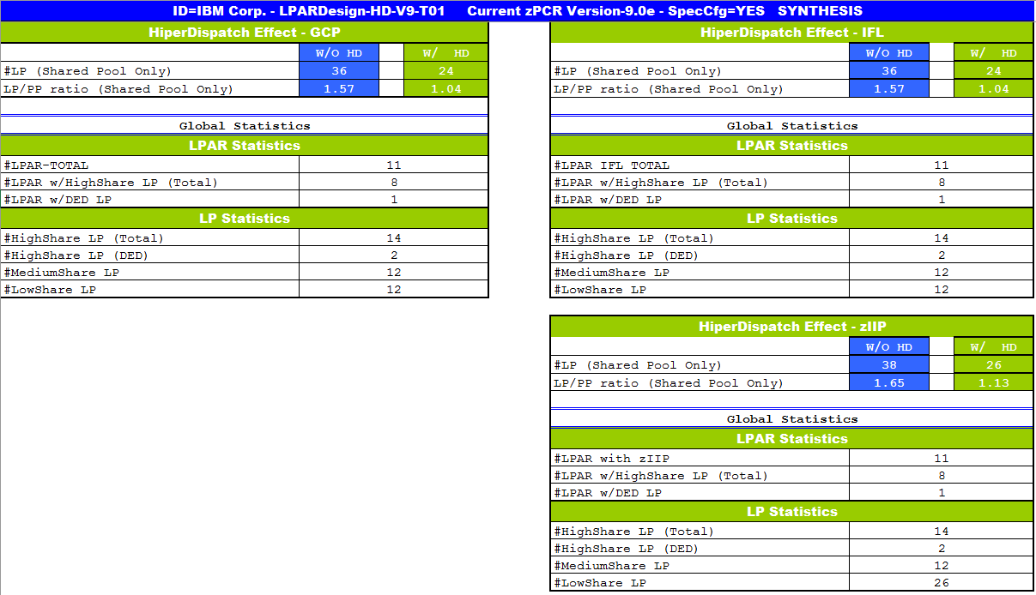

With these numbers, you can figure out how many VH, VM and VL you have.

You can see the HiperDispatch® effect on the number of actual active LPs.

## EXPERT SPREADSHEET Usage.

EXPERT is available for CGP, zIIP and IFL. The layout is as follow:



You can have a direct access to a particular EXPERT Note in using the  Icon on the navigation BAR.

When the note advices you to increase a Weight, you will now have the amount of this increase.

Obviously, the calculation can only be done at constant Total Weight – so if you increase the Weight to xx for an LPAR, you must decrease the Weight from xx for another LPAR.

Here is an example of what is provided in this specific case:

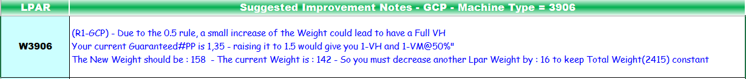

### EXPERT Notes for GCP.

When you push the  button (old way), or the  Icon, you may (or not) have advices on how to optimize your current configuration.

Here are the current rules used to provide these advices:

#### The rules used for advices in GCP:

Rule#1:

If you have 1 VH and the decimal part is between 0.35 and less than 0.5, you can have 1VH and 1 VM@50% if you raise your Weight to have the decimal part to at least 0.5. Otherwise, you will have two VM.

* On z13, this rule is no longer valid: a new way of calculating the spread of LPs has been provided for an LPAR which has 1VH and 1VM@x%.
* On z13, whatever the x% is, you will get 2VM@[(1+x)/2]%.

On z14, the 1.5 rule is back.

Rule#2:

Same than Rule#1, with more than 1 VH.

Otherwise, one VH will be moved to the VM pool.

Rule#3:

If the decimal part is higher than 0.80 (meaning that you are not far from having a new VH), a small increase in the Weight could lead to have a new VH.

There is now (V11T02) two ways of using this rule:

The current way where you can have one more VH, but removing some LPs

The new way where you can have one more VH AND keeping the same number of LP.

Let see in an example: suppose you have this configuration:



LPAR W015 has an entitlement of 1.960 CP which provides 1 VH and 1 VM@96%

Now let see what is recommended by the EXPERT process:



So now you have the choice of being flexible or not in implementing this recommendation.

Rule#4:

It is the opposite on Rule#3.

If the decimal part if lower than 0.05 (meaning that you potentially burn an existing VH), decreasing the Weight could lead to have a VH.

Rule#5:

This is just a warning to remind you that if you have defined 2 LPs and you do not have a VH, the second LP (which is a VL) will always be Unparked.

This rule applies to all machines but the z14.

Rule#6:

This is just a warning to remind you that if you have an integer number of VH and you have defined more LPs that VHs (so having VL), one VH will be in fact a VM@100%.

Rule#7:

This is to alert that you have specified less LPs than needed but you have set ACCEPT SPECIAL CONFIG to YES.

This will influence the HiperDispatch® calculation of VH, VM and VL for the other LPARs.

This is the case for what we call WHITE SPACE LPARs.

Rule#8:

The number of LP must be set properly for not having so much VL. A best Practice document is available as a TechDoc TD106388. This Rule warns you if you are above the recommendation of this Best practice.

Here is a partial example of what is produced:

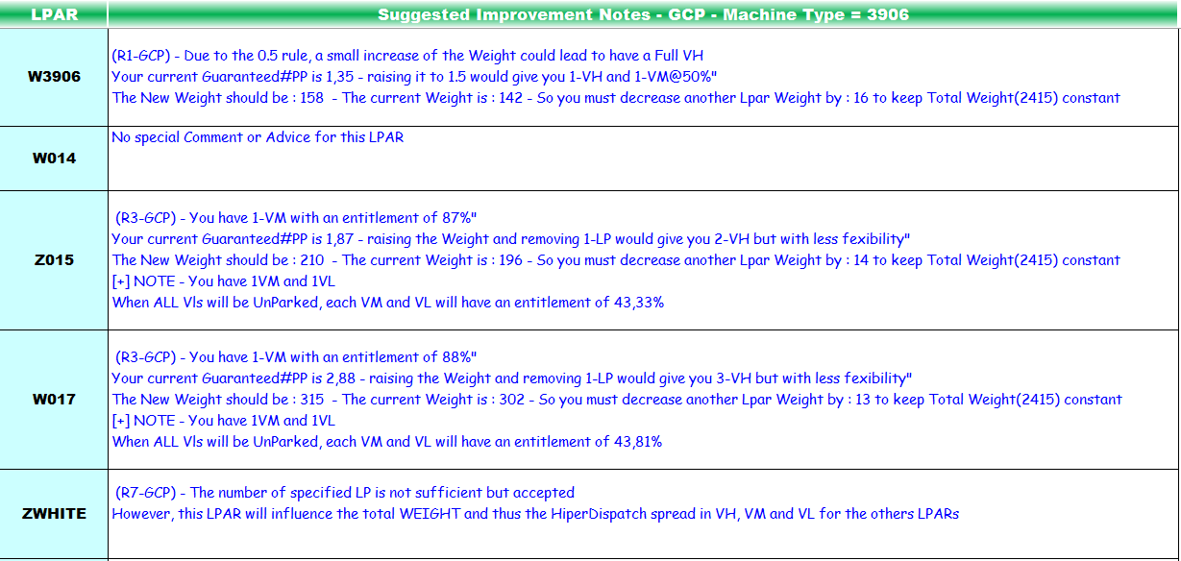

The Rule number of the advices is shown in the line.

If no advice is found you will have the text “”.

A final pop-up window will show you how many LPARs have advices:

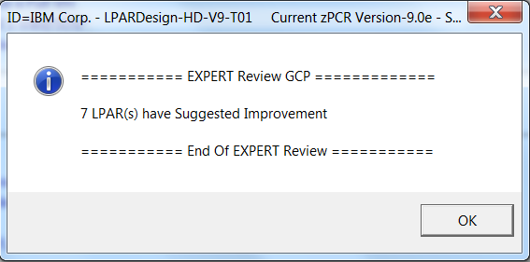

Note : This facility is only available if you have a valid configuration.

## EXPERT Notes for zIIPs.

EXPERT notes are provided for the zIIPs configuration in clicking on the  button (old way) or clicking on the  Icon on the navigation BAR

Mots of the rules are quite the same as for the GCPs.

Here are some specific rules for zIIP:

Rule#9-zIIP:

Informs that the %Share of the zIIP for this LPAR is low (as shown for LPAR W020).

The message is currently triggered if the %Share is less than 5%.

Rule#10-zIIP:

The number of LP must be set properly. A best Practice document is available as a TechDoc TD106388. This Rule warns you if you are above the recommendation of this Best practice.

Here is a partial example of what is provided:

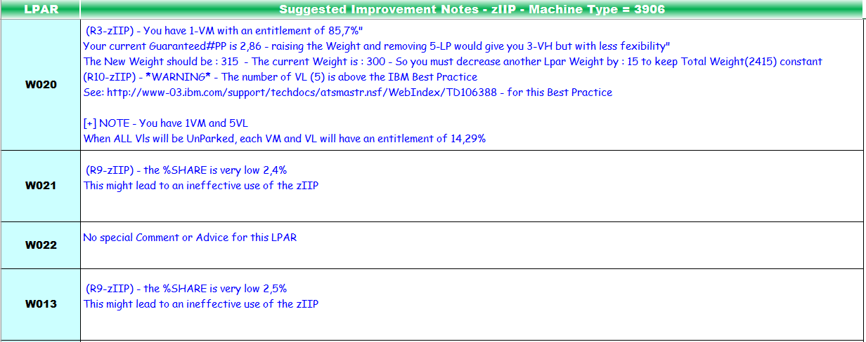

## EXPERT Notes for IFL.

EXPERT notes are provided for IFL when you press the  button (old way) or clicking on the  Icon on the navigation BAR.

.

The rules **are the same as** for GCPs.

## DASHBOARD SPREADSHEET Usage.

This graphic is generated when you push the button related (if appropriate) to the PU type you select.

We have 4 types : GCP, zIIP, IFLs and ICFs as shown below.

You can go directely to the appropriate DASHBOARD using the  Icon on the navigation BAR.

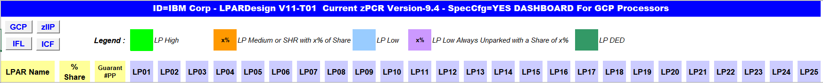

The first lines show a legend explaining the colors of the different LPs assignements.

The following lines (by LPARs) gives the layout of each LPAR:

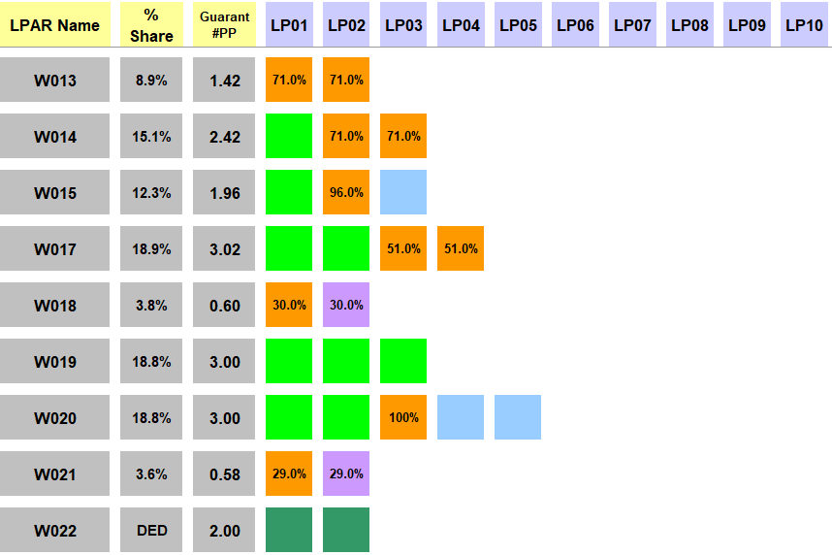

For example, we can see that:

LPAR W013 has 2 VM@71%

LPAR W014 has 1 VH and 2VM@71%

LPAR W015 has 1VM@96% and 1VL

LPAR W018 has 1VM30% and a VL@30% always unparked

LPAR W020 has 2VH, 1VM@100% and 2VL.

LPAR W022 has 2 DED LPs – The color is in dark grey.

The graphic is not limited to 25 LPs (LP**0** to LP**25** as shown in the above first picture, if you have more than 25 defined LPs you will get this layout:

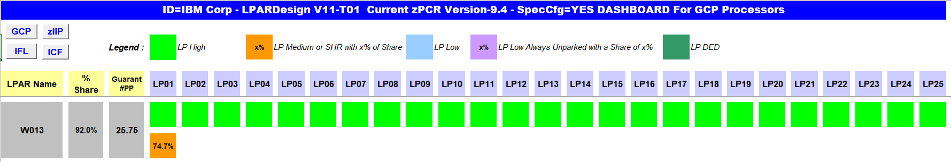

The W013 LPAR was defined with 26 LPs – so a second line is started for the 1 remaining LP (and son on) .

### DASHBOARD for zIIP enhancement.

When an LPAR does not have a zIIP allocation, this LPAR will be in dark grey color in the DASHBOARD

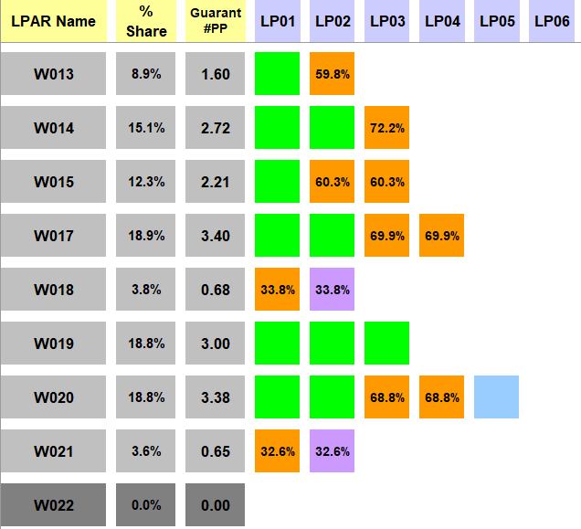

LPAR W022 does not have a zIIP allocation

# LINK with zPCR .

## General considerations on this feature.

This feature helps creating a zPCR Basic study file from LPARDesing or to upload in LPARDesign an existing zPCR Basic study file.

button located in the CONFIG worksheet.

Or use the  Icon on the navigation BAR.

To generate a reliable zPCR Basic study file, you need to have your GCP, IFL and zIIP configurations validated. As you know, every time the spreadsheet is loaded, the cells containing the configurations validations status are set to NO, so, **all the configurations validations MUST BE DONE**.

If you do not perform this process, you will have the following error messages:

Example for GCP:

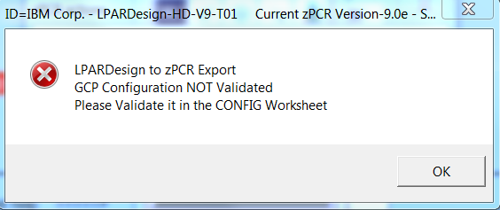

## Current limitations of the link to zPCR feature.

### Specifying an LPAR with unsufficient number of LPs to sustain the share

This could lead to have a problem when this LPARDesign study is exported to zPCR.

zPCR requires that you set at least one LP, but you will face the problem that you do not have sufficient LPs to sustain the share.

In this case you will have this zPCR message:



### Processors type.

HiperDispatch® is available on the z/OS operating system on GCP, zIIP and IFL processors types.

To make the study with zPCR easier, we have added the support of the ICF, even if ICF are not HiperDispatch® eligible.

### Reference CPU.

We use as a reference CPU.

Again, you might be led to change this default.

### zPCR Version.

The LPARDesign code is usualy in sync with the latest zPCR version. The current supported version is displayed in the message boxes. zPCR usualy allows that a study with the n-1 version to be uploaded.

### z/OS Version.

In this current release of LPARDesign we have set the z/OS Version to the LSPR Version so **z/OS V2R4**.

## Using the zPCR EXPORT feature.

This feature export the current LPARDesign definition to a zPCR Basic study file.

button or use  in the Task Bar.

This box is displayed : 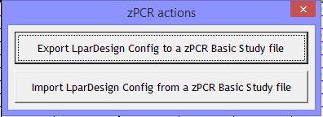

Click on the **Export LparDesign Config to zPCR Basic study file** button.

Then and according to your CPU Model this information box is displayed:

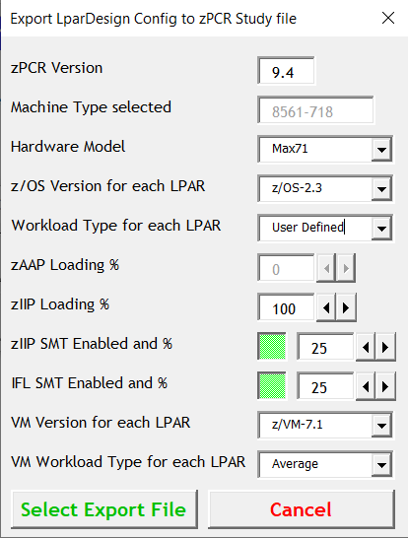

Note: In certain situations, you might have to properly set the actual Hardware Model.

A field is displayed where you can select how you will process the setting of your worload characterisation:

If you select “User Defined” the export will take what you have set in the CONFIG spreadsheet.

Otherwise, you can choose a worload characterisation in the list:

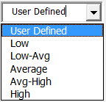

In this case, **all the workload will have this characterisation** set in the zPCR study file.

You have to select these useful informations to create a proper zPCR Basic study File:

* The Hardware Model
* The z/OS or zVM version
* The workload type
* The zIIP Loading %

Then you have to select the name of the zPCR study file.

By default, we propose the current LPARDesign file name with a suffix of .**zpcr** as shown below:

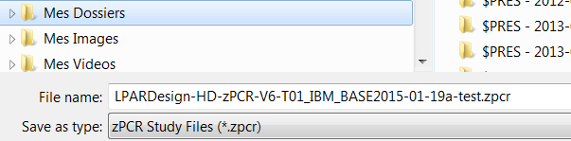

You can select the folder and the file name. Then select SAVE and you will receive this message box specifiying your choices:

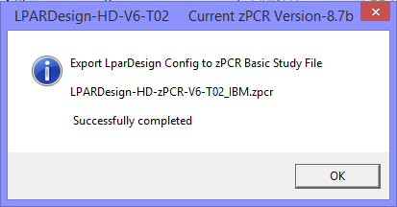

## Using the zPCR IMPORT feature .

button or use  in the Task Bar.

This box is displayed : 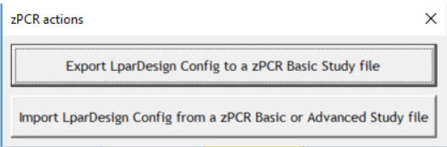 :

Click on the **Import LparDesign Config from zPCR Basic or Advanced study file** button.

The Windows file selection appears an select your zPCR Basic study file:

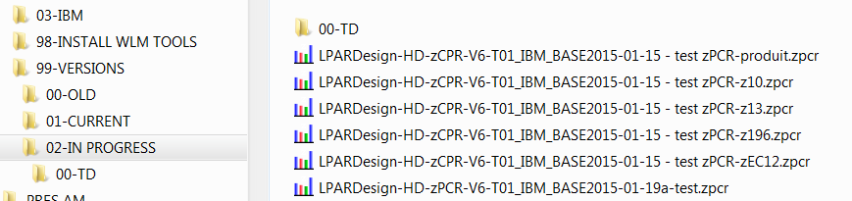

Click Open and your zPCR Basic Study File will be uploaded in the LPARDesign spreadsheet

You can now choose which configuration you want to Import : 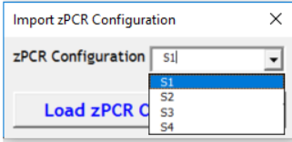

.

Let’s suppose you have chossen the S2 configuration, a message box will appear to show you file selection:

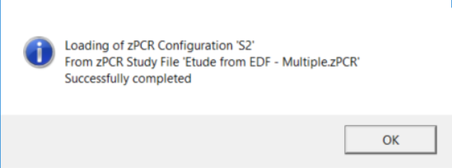

You are now in LPARDesign again and have to run all the appropriate function to validate your configuration.

*Note : As zPCR only take into account active LP, if you Export to zPCR a configuration and then Import from zPCR the preceding exported zPCR file you could see some differences in the number of LP per Lpar. So be careful.*

# PRINTING THE SHEETS.

The print parameters have been set for most of the sheets to provide a common layout.

You print the sheet in displaying it and selecting the  button in the action bar.

Some sheets like **SINET** and **Tables** cannot be printed using this button.

When you hit the Print Button you will have the standard pop-up:

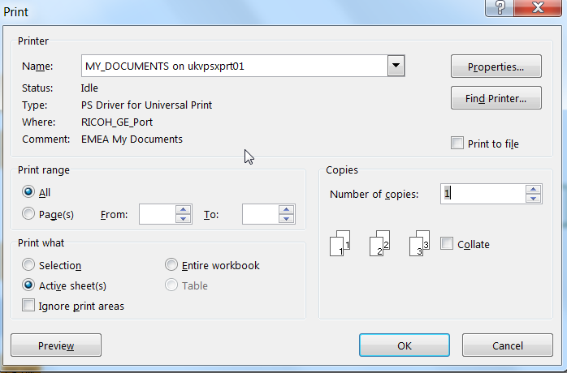

You can change the Printer Name, check the output using the Preview button or print directly the sheet.

# FAQ, COMMON MISTAKES AND RELEASE RECOMMENDATIONS.

## FAQ

***Q1 - When I open the workbook, the GCP, zIIP or IFL VALIDATION is set to NO.***

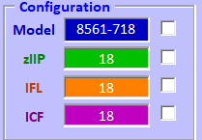

R1 – This is the standard behavior. The Config Validation must be done after an open (re-open) of the workbook, which is why these fields are forced to NO. This is for data consistency.

***Q2 – I want to calculate the HiperDispatch® LP configuration for zIIP, but the tool says that the configuration does not support HiperDispatch® or the GCP configuration has not been verified.***

R2 – When you have zIIPs, you must go first to the CONFIG spreadsheet, run the Config Validation and HiperDispatch® for GCP, and then go to the CONFIG-zXXP spreadsheet to be able to run the calculation.

***Q3 – zPCR Version***.

In the spreadsheet, the zPCR version is “hard coded”. But as soon as a new zPCR version is available, the spreadsheet is updated and uploaded on the WLM Web Site.

***Q4 – I am not an IBM employee, so how am I informed that a new version of zPCR is available?***

R4 - To have the latest version go read chapter 4 : HOW TO GET THE PRODUCT – IMPORTANT NOTICE:

Or send a mail to [**alain_maneville@fr.ibm.com**](mailto:alain_maneville@fr.ibm.com)

***Q5 – When I open the spreadsheet I have security messages – how can I get rid of them?***

This almost happens when you open a new version for the first time.

You might get the following message:



What you must do now is simple:

Click on the “click for more details” area.

You will get this other message:

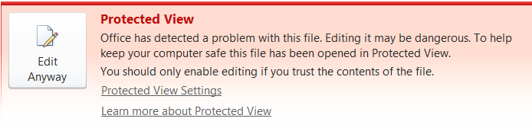

Then click on “Edit Anyway”

You will have this VB error message:

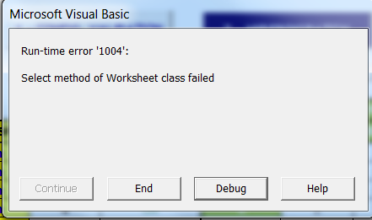

Then click on “End”

Save the spreadsheet

Re open it and all should be fine now.

## COMMON MISTAKES.

**M1** – **Do not delete the remaining rows in the CONFIG, CONFIG-IFL or CONFIG-ZXXP worksheets even if you have less than 30, 40, 60 or 85 LPARs (which is mostly the case). If you do so, it can generate error if a new calculation is required**.

* You have the **DELETE LPAR** feature that will help you to properly delete unwanted LPARs.

**M2** – Even if you do not have zIIP, set the number of LP to zero or let it blank or set the Weight to zero or let it blank and validate the configuration if you want to use the zPCR link. Otherwise you will get an error message.

**M3** – Never delete a row in the spreadsheet.

They will be cleaned automatically and remember that you have now the **DELETE LPAR** feature.

**M4** – Try to use a fresh copy of the spreadsheet – use the Create a Copy feature and/or the Save as feature.

**M5** – If no zIIP are to be used, set 0 in the #zIIP in the START spreadsheet.

**M6** – In the list of available machines, you might find generic names like “Systems z13s” or z13-4XX. Those are NOT machines that you can select, they are pointers in the list to help you find faster the machine you want.

If you select these generic names, you will get this pop-up message:

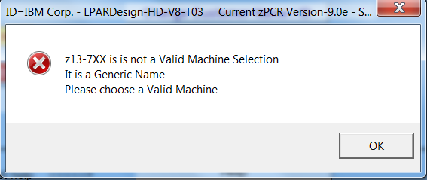

* For **IFL only machines** with no GCP, select machine like z13-4**00**, zEC12-7**00**. “**00**” means NO GCP.

**M7** – When I change the CPU Type / # of processors and so on nothing changes:

Starting with V9-T01, we have introduced an “action bar” that makes travelling in the sheets easier.

So, after a change in the START sheet, **you must use one of the “travel” buttons (GCP, IFL, zIIP)** to go to the appropriate sheet. This will, under the cover, checks the changes you have made and modify (if checks are ok) the configuration. If you travel in just clicking in the sheet name (in the workbook), some changes might not be done.

**M8** – Rounding

Sometimes, the rounding of the result of a division (e.g.: Weight/Total_Weight) then multiplied by another number might give potential wrong information.

This is sometimes the case when calculating the number of guaranteed Physical Proc.

These rare cases happen in the EXPERT sheet when calculating the new Weight of a recommendation.

In this case, send a mail to the support and we will figure out how we can fix this case.

## RELEASE RECOMMENDATIONS:

**R1** – Use the new navigation BAR to “walk” within the different worksheets. Use the actions buttons to validate the configuration, see the messages, see the EXPERT advices and the DASHBOARD layouts.

Note : the previous actions are not available in the CONFIG-MSU worksheet as they are not appropriate in the sheet.

Here it is again:

If you want to change the Configuration Go to Start – other Icons are fast access when you work in a specific PU type.

To read some spreadsheet easier, you can use the Minimize/Maximize button to “make room”. When in Minimize configuration, the BAR will only use this space:

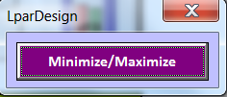

# RECOMMANDED USAGE WORKFLOW

To make the study as simple as possible and to minimize the manual data entries (like LPAR Name, Weight, #LP, Workload characterization), its is recommended to use this worrflow:

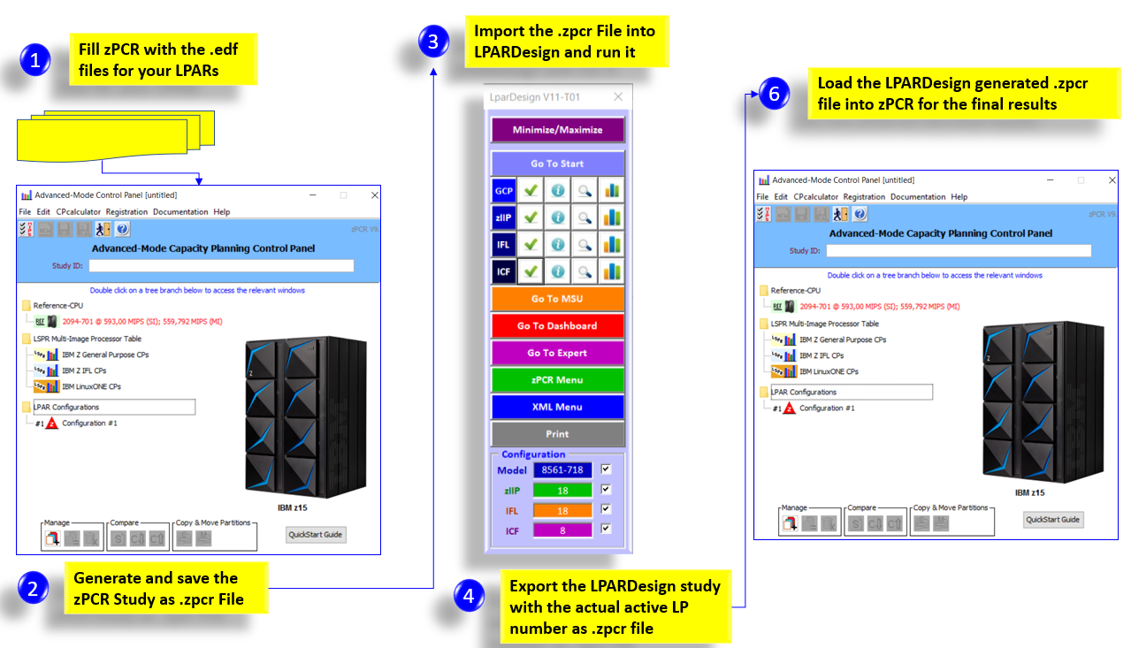

END OF DOCUMENT - Lpardesign-HD-Zpcr-V14-T02_AMTD_Userguide.Docx